OBJECTIVES:
- Analyze data.
- Define ratio.
- Find percentages.
- Use proportions.
- Do conversions.
- Find probabilities.
- Interpret two-way tables.
- Interpret bar charts.
- Interpret scatterplots.

WEDNESDAY (9.4.24)
- Check your answers for the previously assigned classwork/homework: SAT Questions #9 – 18 on the handout.
- Discuss how you solved #9 – 13.
- Finish #14 – 18 if you have not already done so.

FRIDAY (9.6.24)
- Discuss how you solved #14 – 18.
- Homework: More data analysis problems. See page 2.

- When y is decreased by ten percent, the result is equal to fifteen percent of x. Assuming both x and y are nonzero, what is the ratio of x to y?
- 1/6
- 3
- 6
- 18
- 1/3
- Nancy is visiting her grandmother who lives 200km from her home. Her car’s tank has a full tank (20 liters) at the beginning of her drive and uses 1 liter to drive 6 kilometers. How many liters will she need to refill to reach her grandmother’s house with 0 liters left in the tank?
A) 13.3 liters
B) 9.8 liters
C) 20 liter
D) She will not need to refill.

3) Students in a school can either choose to have a hot dinner or packed lunch. The table below shows some information about the choices of the 4th grade students:
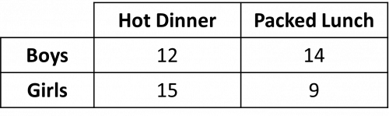
a) One of the students is chosen at random. What is the probability that they have a packed lunch and are a boy? Give your answer as a decimal. ________
b) One of the students who chose a hot dinner is chosen at random. What is the probability that they are a girl? ___________
4) The table below shows some information about the number of employed and unemployed people in a town.
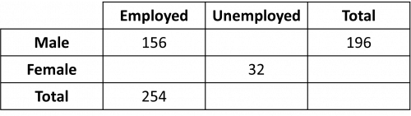
Find the probability that a person chosen at random is unemployed. Give your answer to three decimal places. ___________

